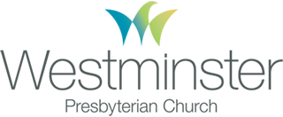
PACKING LIST

youthworks.com

For Everyone

CLOTHING
As you pack clothes for your trip, make sure you’ve read the page entitled “Clothes to Pack for Your Mission Trip.” It has lots of information to help you pack well!
 Mid-thigh or longer shorts*  Long pants
for cool nights and/or work projects  Short-sleeved shirts*
 Long-sleeved shirts, sweatshirts and/or light jacket for cool nights
 Nice-ish, clean clothes for a church service  Underwear and socks
 Tennis shoes or work boots (closed-foot)*  Swimsuit*
for showering if you wish and/or possibly for the boardwalk
 Towel and washcloth
 Shower shoes (flip-flops)

OTHER STUFF
 Small shower bag or backpack
 Lots of wipes! (No more than 2 shower days)
 Soap, shampoo, deodorant, other toiletries, extra contact lenses, backup pair of glasses, etc.
 Sleeping bag and pillow
 Air mattress or camping pad
for sleeping on floors; mattresses must be twin size or smaller
 Bible and pen
 Reusable water bottle
 Sunscreen, lip balm, hat, sunglasses
 Spending money for snacks and other purchases
 Insect repellant
not every person needs to bring their own; coordinate with others in your group
 Flashlight
 Battery-powered alarm clock
not every person needs to bring their own; coordinate with others in your group

.

WPC Youth – 415.383.5272 x218

Notes on Packing

Because space is limited in the vehicles, everything but your sleeping bag and camping pad or air mattress should fit in one duffel bag or suitcase.
Please check the local weather forecast for the community you are visiting to help you know how to pack.
Current forecast for Santa Cruz:
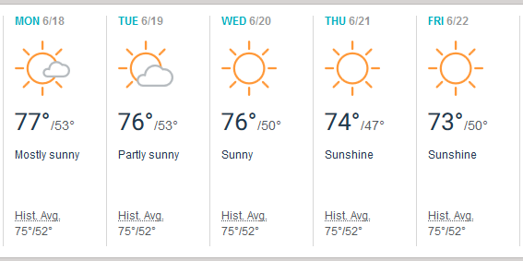

PLEASE AVOID BRINGING:
Blow dryers, curling irons or straightening irons because if we get shower time it will be short and because many of our housing sites do not have the power to run all of these small electronics at one time.

Electronic devices, too much cash or other valuables. Also, consider leaving your phone at home. These items can distract you from others during the week and may be susceptible to theft. Westminster Presbyterian Church, Peace United Church of Christ, and any of our other partner organizations are not responsible for any lost or stolen items.

CLOTHES TO PACK FOR YOUR MISSION TRIP

youthworks.com

Clothes to Pack for Your Mission Trip

We want you to be successful in service! It might seem small, but being intentional with what you wear can help you eliminate obstacles when serving others. Because we get to be guests in another place, we want to do everything we can to respect others, including honoring their ideas about apparel. Plus, we’ll be doing a lot of different kinds of service, so we want you to be ready for whatever this mission trip throws at you!

Bringing the following items on your mission trip will allow you to bypass potential barriers, participate in all sorts of service, and stay safe as you enter into another community and actively love others.

Please Bring…

Tennis Shoes or Work Boots
You can bring sandals too, but to keep your feet safe, you’ll need a pair of closed-foot shoes that completely covers your feet. Bring footwear that you don’t mind getting dirty or wet at service sites and that you can wear in the kitchen.

Mid-Thigh or Longer Shorts or Pants
Not sure if that’s your shorts? Let your arms fall to your side; if your fingertips touch skin, look for a longer pair to bring along.

Shirts with Sleeves
They don’t have to be long sleeves and you can roll them up anytime.

Loose-Fitting Clothing
During the week your clothes may endure paint, sweat, dirty dishes, mud and lots of love from children! Bring clothes that you can work and play hard in.

Swimwear for the Beach
Understanding that clothing can be a stressful issue especially at the beach we simply ask that you be thoughtful and considerate that you’re representing a church if for only these several days.

Please Leave at Home…

• Short shorts
• Clothing that reveals undergarments, midriffs or chests
• Tight-fitting clothing
• Clothing with obscene, vulgar, abusive or discriminatory language or images
• Attire that represents hate groups, contains threatening language or is gang-related
• Apparel that promotes alcohol, chemicals, tobacco or any other product illegal for use by minors

Why?
We don’t want something as simple as clothing to hurt your opportunity to form incredible connections with our host church on the trip or our friends in the community. Instead, we want to honor those relationships by avoiding attire that could possibly conflict with their cultural or organizational norms.
We know that some of the items on this list might not match up with what you usually wear. Sometimes service stretches us beyond what we’re used to… and that’s OK! Mission trips are all about moving into new territory and experiencing something different. Plus, it’s kind of incredible that something as simple as how you pack your bags can be part of the way you begin to serve the community you’re headed to. Thank you for serving in this way!

WPC Youth – 415.383.5272 x218 Jeff@WPCTiburon.org

